**User Manual**

**for**

***Minute Math Racer***

Version 1.0

April 21st, 2015

**Prepared by:** **Samuel Arseneault, Kelly Markaity, John Luu**

Table of Contents

**1. Overview** 1

**2. Using the Web Portal** 2

**2.1 Getting Access** 2

**2.2 Creating an Apple ID** 2

**2.3 Download and Install** 2

**2.4 Web Portal Navigation** 2

**2.4.1 Creating an account** 2

**2.5 Navigation the web site** 4

**2.6 Class Editor Tab** 4

**2.6.1 Adding/Deleting a class** 4

**2.6.2 Adding/removing a student** 5

**2.6.3 Updating student password** 6

**2.6.4 Viewing student progress** 6

**2.6.5 Clearing student progress** 7

**2.7** **Level Editor Tab** 7

**2.7.1 Creating/removing a level** 7

**2.7.2 Add/removing a question** 8

**2.8** **Import/Export Tab** 9

**2.8.1 Importing Levels and Questions** 9

**2.9.1 Updating account name** 10

**2.9.2 Changing account password** 10

**3.0 USING THE iOS APPLICATION** 11

**3.1** **Logging into the application** 11

**3.2** **Selecting a level** 11

**3.3** **Selecting a type** 13

**3.3.1 Level type: Practice** 14

**3.3.2 Level type: Test** 16

**3.4** **Going through the questions** 16

**3.5** **Submission overview** 19

# **1. Overview**

The Minute math racer application was built and created to give first graders in elementary school a useful tool to aid them in learning. This application is targeted towards addition mathematical problems that correspond with the common core math standards.

Within the application a student will log in using a classroom credential that is created by a teacher they are assigned to. A username and password will also be created by the teacher that will allow a student to sign in to the application itself. Once inside the application, a student will have the ability to select a level in which they can choose to practice or take a test to advance to the next level of questions. A student may not select a level unless the student has pass the test of the previous level with a 100% accuracy.

If a student has selected the practice section of a level, the student will be able to go through questions and will receive feedback if an incorrect answer has been submitted. In the practice section, the students will be able to practice their math addition problems without a time limit constraint.

If a student has selected a test section of a level, the student will be able to go through questions of the same format they saw in the practice section. In the test section, there will not be any visual cues indicating a correct answer and will automatically continue to the next question after they have submitted their answer. At the end of the test section the students will be able to view any questions the students entered incorrectly. The end of level view displays the questions that were not correct, the answer the student submitted and the correct answer for that problem.

In addition to the mobile application, a web portal has been created for a teacher/educator. In the web portal the teacher has the ability to create classes and to add students to those created classes. After a class has been created along with the students within the class, the teacher has the option of using a set of default addition problems or to create custom levels and questions. Other options the teachers have available are the abilities to: remove student’s, remove classes, add/remove questions, add/remove levels, updating a student’s password, viewing individual student’s progress, importing/exporting custom level configurations, updating the teachers name on the web portal and updating their password. You can visit the website: <https://minutemathracer.com/WebPortal2/login.php> to get started.

# **2. Using the Web Portal**

This section of the manual will help teach new using get started with using the web portal.

## **2.1 Getting Access**

Getting access to the mobile application and the web portal will require a internet access, a computer or laptop with web accessibility. An Apple iPad with iOS 7.0 or later will also be needed in order to interact with the application portion. Once the user is on a device with internet accessibility, they can visit the site: <https://minutemathracer.com/WebPortal2/login.php> to get registered.

## **2.2 Creating an Apple ID**

To create an Apple ID please to proceed to Apple’s website: <https://appleid.apple.com/account?localang=en_SG> and follow the instructions provided by Apple to create a new account. For existing account users please skip this step.

## **2.3 Download and Install**

In order for a user to download and install, they must create Apple ID and password for them to proceed (refer to section 2.1.0). The application will be available on the app store after Apple approval or via Test Flight.

## **2.4 Web Portal Navigation**

### **2.4.1 Creating an account**

To create an account on the web portal, you open up your web browser and go to the URL <https://minutemathracer.com/WebPortal2/login.php>.

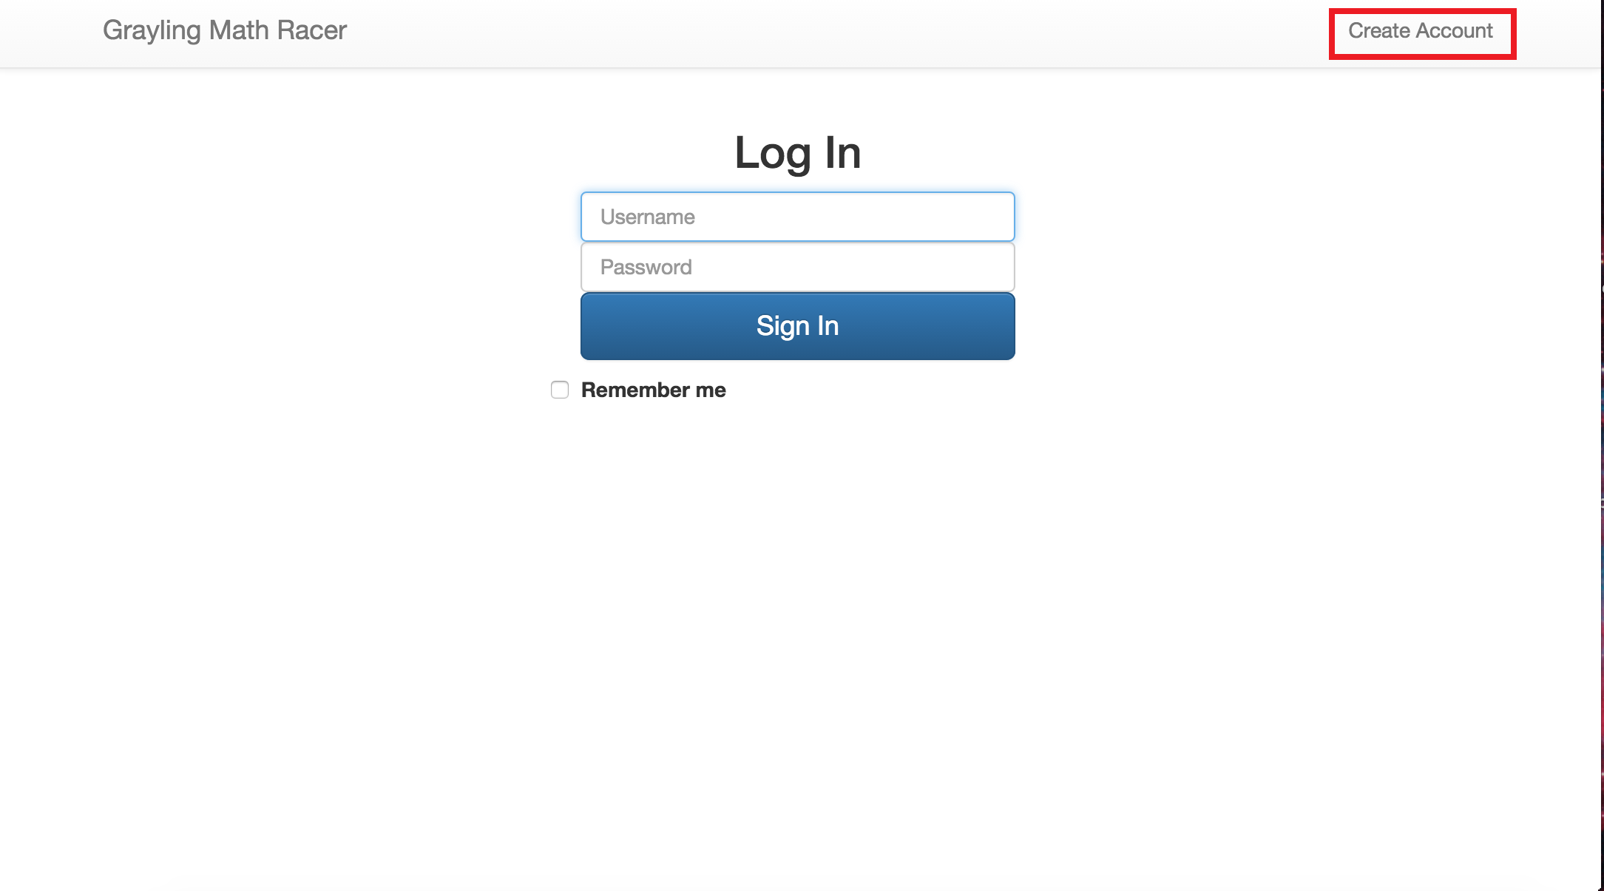

*Figure 1*

Once you have navigated to the web portal you can click on the “Create account” button on the top right of the screen. The picture above with the red box demonstrates the location of the button(figure 1 above). This will take you to the next page where you will fill out your information pertaining to your name, username, password and a password confirmation. After you have clicked on the “Create account” button on that page you will receive a notification at the top of the page to confirm your account creation(figure 2 below). After you receive that notification you can click on the “Login button on the top right corner to proceed.

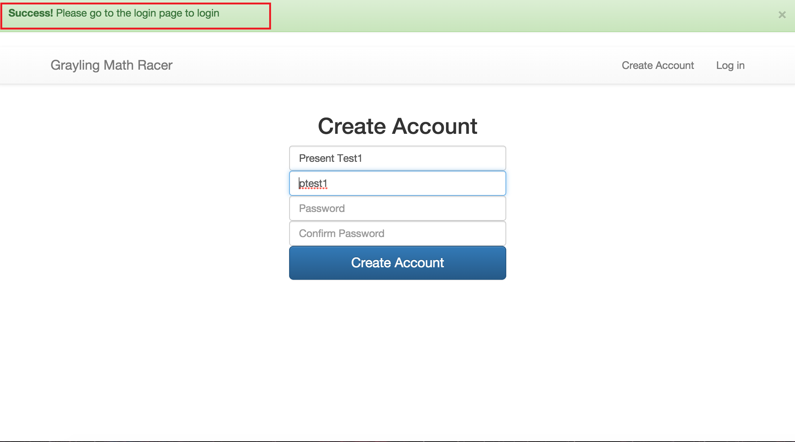

*Figure 2*

## **2.5 Navigation the web site**

Once your account has been created from the previous steps you will notice your landing page is pretty bare and you have several tabs to choose from. From this page you have the option to go to the class editor, level editor, import/export page, and account page. We shall begin with the class editor page in our next step.

## **2.6 Class Editor Tab**

### **2.6.1 Adding/Deleting a class**

On the class editor page you will notice that there are not any students or a class registered to your account if this is your first time using the web portal. To begin you will click on the “Create Class” button.

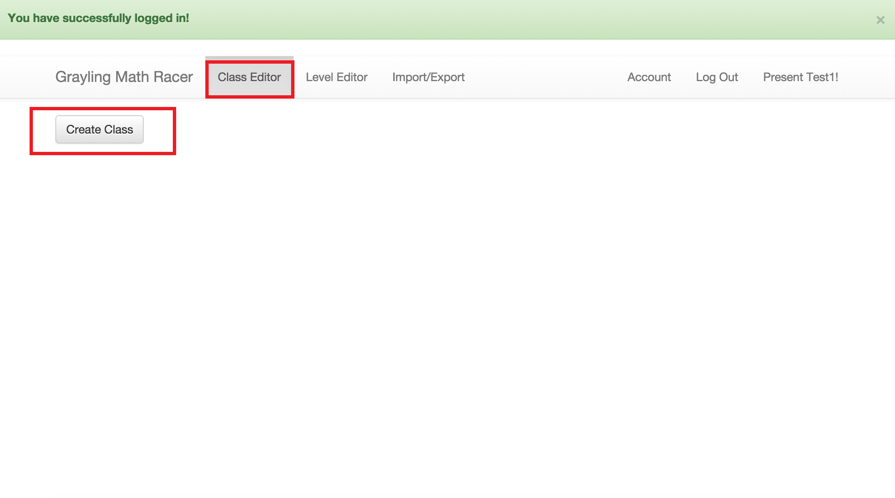

*Figure 3*

From here you will be prompted to fill out basic information about your new class. You will need to enter the teacher’s name, a name for the class, a password for the class, and the password again for confirmation. Once completed the user will be redirected back to the class editor page. Here, the user has the option to remove a class or to begin adding students.

### **2.6.2 Adding/removing a student**

Now that you have a created a class it’s time to add students! After clicking the “Add student” button a pop up box will appear with five description fields that need to be filled: First name, last name, username, password and confirming the password. Once the fields have been added you will be redirected back to the class editor tab and you will notice that the student has now been added to your class.

Removing a student is achievable through the class editor tab, while viewing your class with the list of students you can select the student you which to remove by clicking on their name. When you click on a students name a box will appear on your screen with the selected students information and at the very bottom right of this box is the option to “Remove student.” When the “Remove student” button has been clicked it will successfully remove that student from your class.

### **2.6.3 Updating student password**

Changing a student’s password is as simple as clicking on a student’s name within the class editor page. When you click on a student’s name a pop up box will appear. At the top of that view you will see the student’s name and right below it, the student’s password. You can enter a new pass and click on the “update password” and the password will be changed (see below, figure 4).

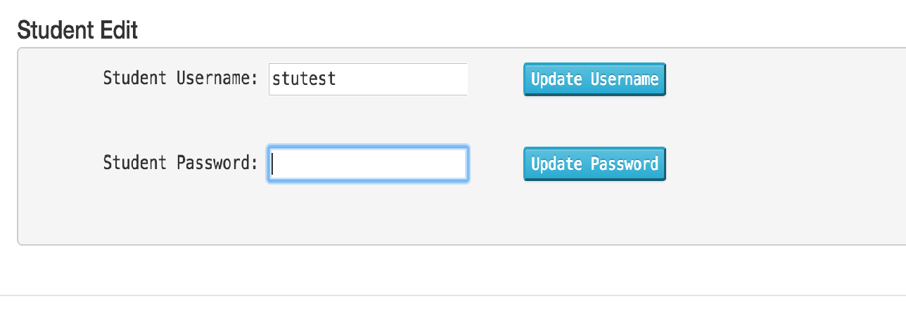

*Figure 4*

### **2.6.4 Viewing student progress**

To view a student’s progress you can go to the class editor tab and view the students that are registered to your class. Selecting a student by clicking on their name will bring up a pop up box. Inside the pop up box will be displayed information and a graph about the progress the student has made within the mobile application. If the student has not yet signed in to the application with an iPad nothing will be displayed at this time. Once a student has used the application and has made an attempt at the practice levels the graph will begin populating and display results such as time spent on each level, what level they have attempted and the number of attempts they have had on each level (see figure 5 below).

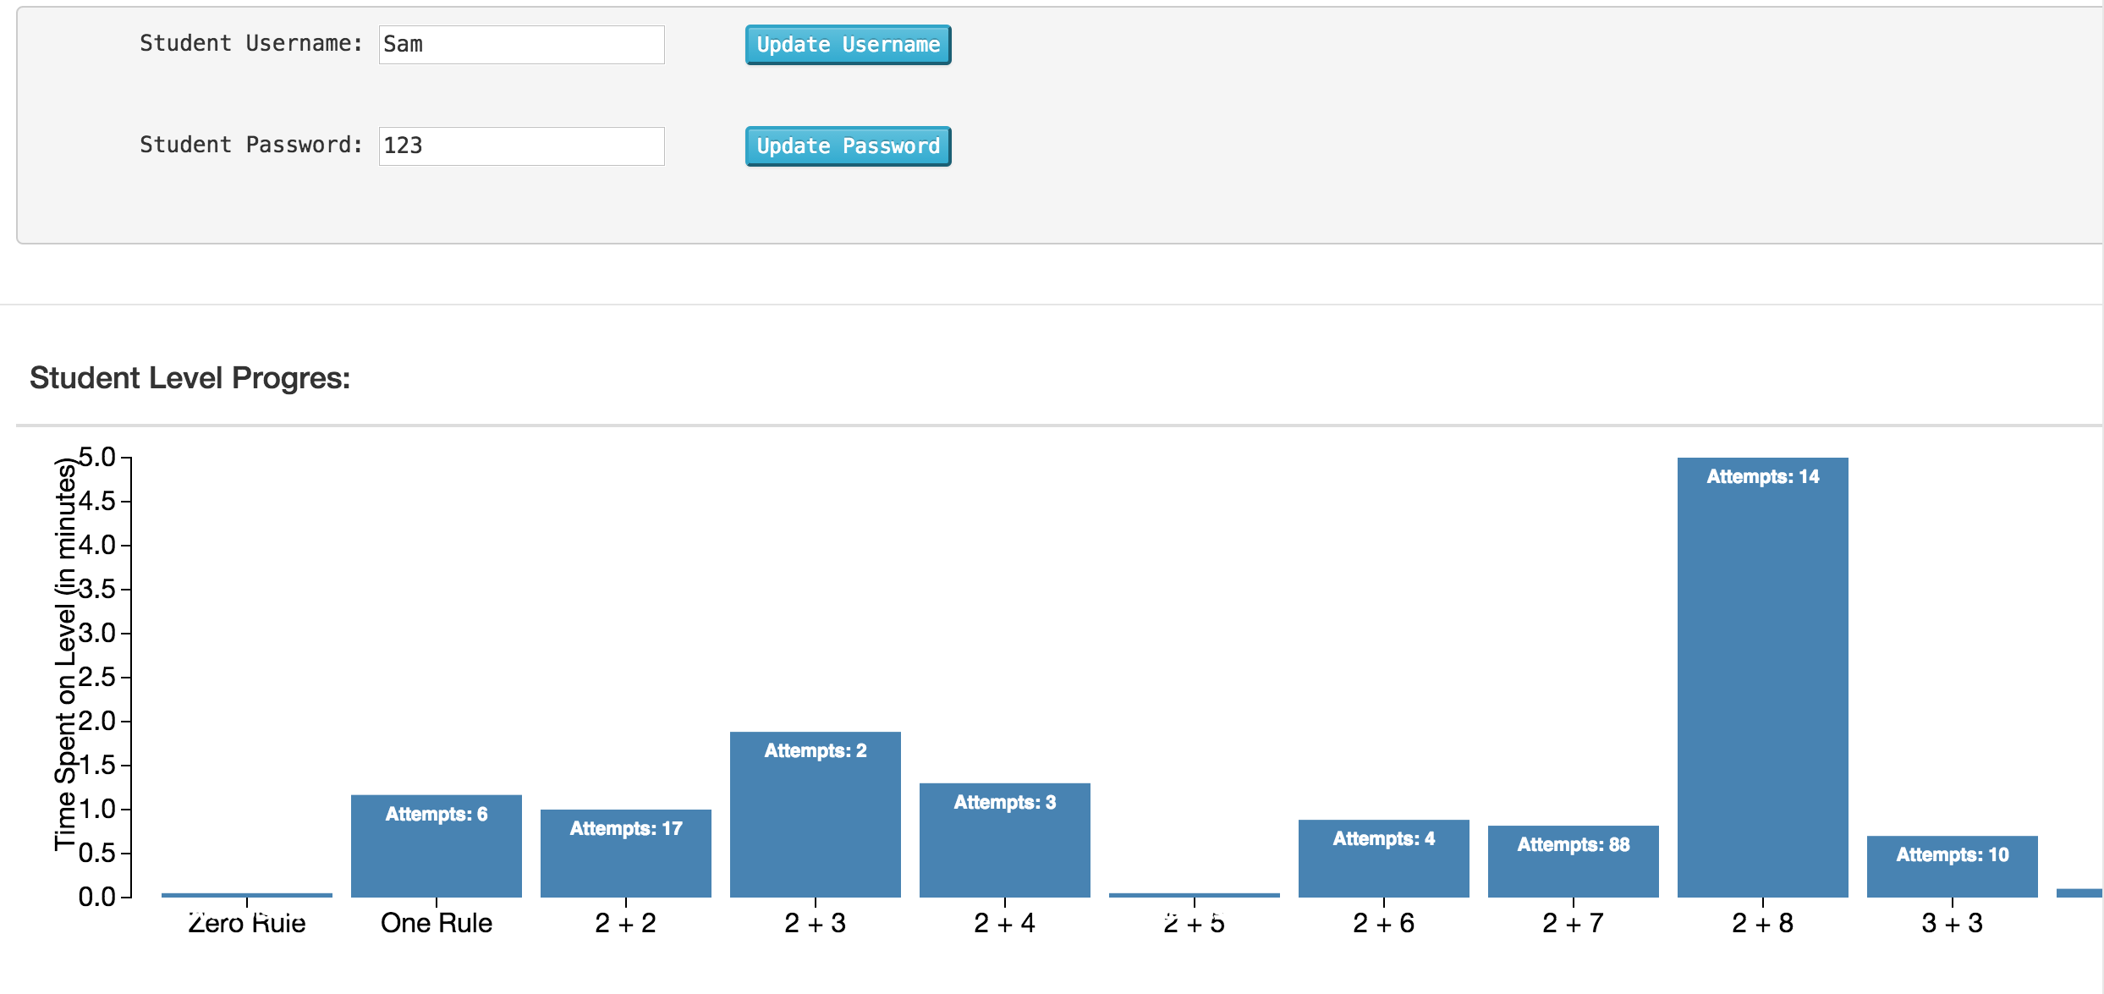

*Figure 5*

**2.6.5 Clearing student progress**

Clearing the student’s progress, if you go to the class editor tab you will be able to view the students in your classroom as well as their progress. If you would like to clear their progress you can go to the bottom of the page of students and simply hit the “Clear Student Progress” button. This action will clear all the progress of the student’s attempts in the mobile application and reset data.

## **2.7 Level Editor Tab**

### **2.7.1 Creating/removing a level**

To add levels for the class to use on their mobile application you can go to the “Level editor” tab. Here you have two options to choose from when adding levels. First you have the “Create Level” button which allows a teacher to create a custom level with their choice of numbers and operators to use. The second option is to load the “Default Levels” in this option if the teachers chooses to use the default settings there will be a set of 18 levels with 18 questions that will populate and allow students to use. After the levels have been loaded or manually created, the teacher can go to the “class editor” tab and will see the levels that were created or pre-loaded.

### **2.7.2 Add/removing a question**

To add or remove questions from a level that was pre-loaded or created custom, you will need to select the “Level editor” tab near the top of the page. In this tab you will see the list of all the levels that were pre-loaded or all the levels that you have manually entered. If this section blank, then that indicates that no levels have been added yet. Locate the question you want to remove by first going to the level that question resides in. When you select the level another list will show up displaying all the questions for that level. On the right hand of the screen you will see a button that states “Remove” (see figure 6 below). Clicking remove will indeed remove the question from the selected level.

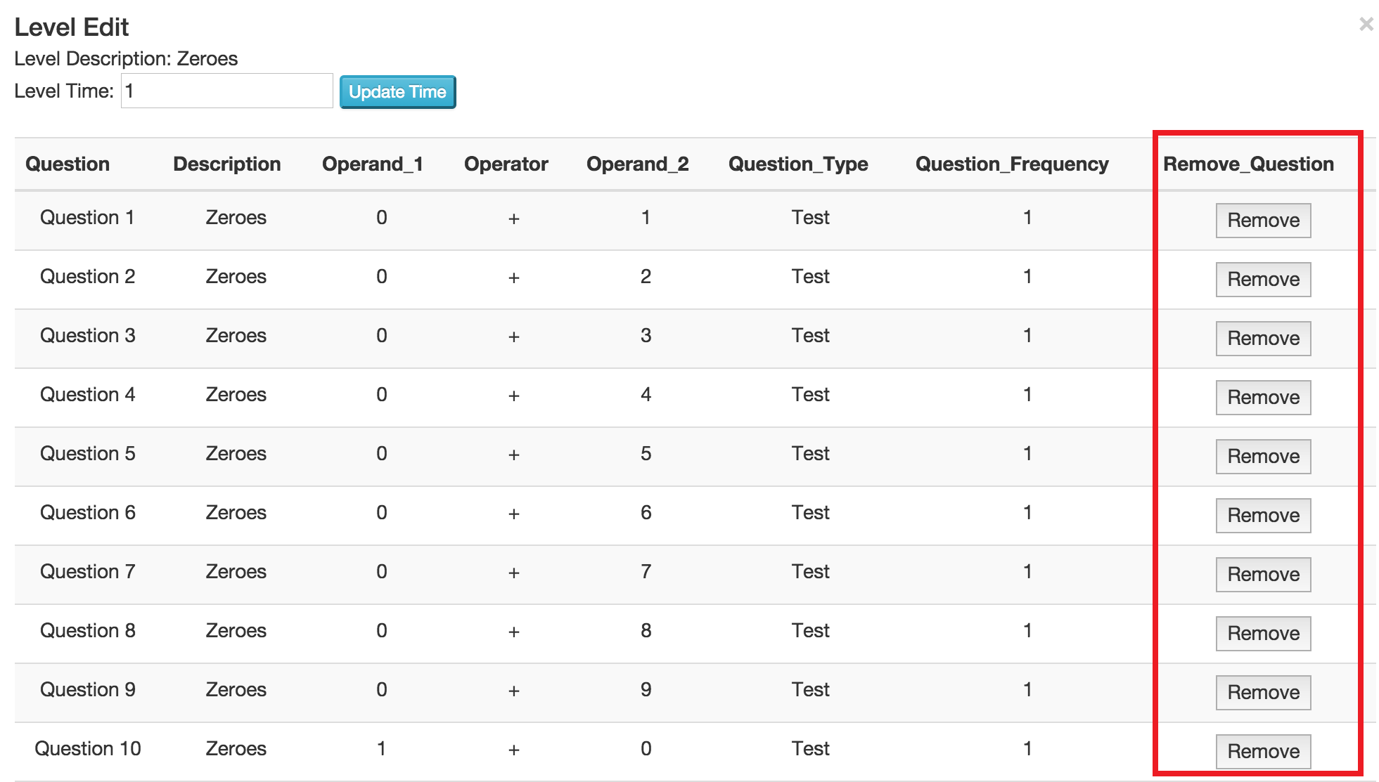

*Figure 6*

## **2.8 Import/Export Tab**

### **2.8.1 Importing Levels and Questions**

To import levels navigate to the import export tab on the web portal site. Under this tab you will see a button labeled “import” and a button labeled “Choose File” (see figure7). To import levels and questions first select the “Choose File” button and navigate to the .csv you have previously created or exported from this site. Once you have chosen the desired .csv file, the name of the file will appear next to the “Choose File” button. Once you have verified this step, you may continue with the process by selecting the “import” button. After selecting the import button you may experience a 2 - 4 minute wait time, until the process is complete. When the web portal has completed importing your file, you will be prompted with a “Successfully uploaded” message (see figure 8).



*Figure 7*

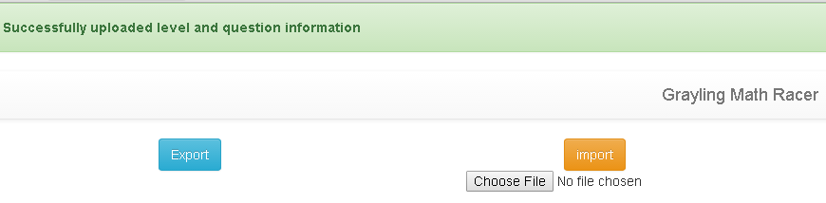

*Figure 8*

**2.9 Account Tab**

### **2.9.1 Updating account name**

To change an account name on the web portal you can navigate over to the account tab once you have logged in. When you click on the account tab it will redirect to you a page with two buttons labeled “Update name” and “Change password” (see figure 9 below). Here you will select the “Update name” button and a small box will pop up. Now you can enter the name you would to be updated to and click the “update” button in the pop up box.

### **2.9.2 Changing account password**

To change an account password on the web portal you can navigate over to the account tab once you have logged in. When you click on the account tab it will redirect to you a page with two buttons labeled “Update name” and “Change password” (see figure 9 below). Here you will select the “Change password” button and a small box will pop up. There are three fields that you have to complete to change your password. The first field that is required is entering in your current password. The second field is where you enter your new desired password. And the last field is entering your desired password again for confirmation.

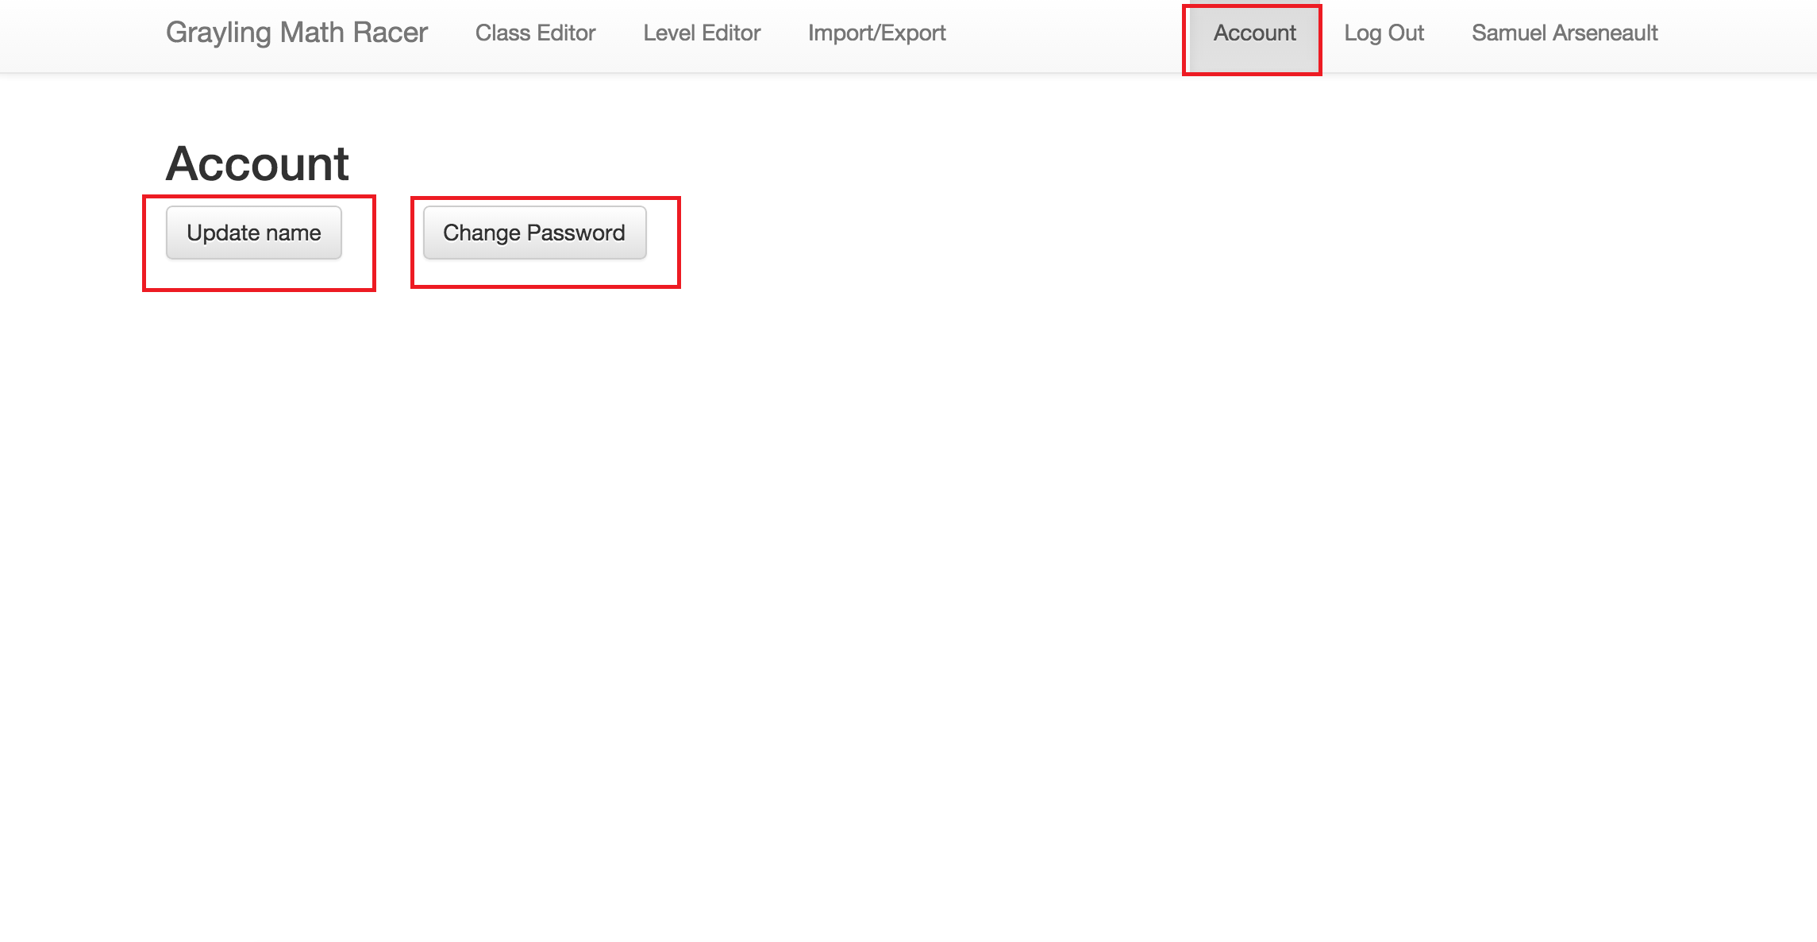

*Figure 9*

# **3.0 USING THE iOS APPLICATION**

Now that you have created an account on the online web portal you are now ready to have your students log into the mobile application. Go to the application that you downloaded from the Apple app store or open the app that you got iTunes TestFlight and click on the icon.

## **3.1 Logging into the application**

The initial instance of using the application will require a student to enter some the teacher’s name and class password for the class login page. After the class login page the student will proceed to the student login page where they will enter their username and password that the teacher had created on the online web portal. If the student is unable to log on please check to make sure the iPad is connected to the internet. If connection is established then go to the web portal and refer to section 2.3.2-1 Adding/removing a student.

## **3.2 Selecting a level**

After the student has successfully logged into the application it will take them to the page with the button that says “Select a level.” When the student hits the “Select a level” button it will take the student to a map with cars on a track. Cars that have color are the levels that are available for the student to select. Levels will be available once the student has successfully pass the test of the previous level with a one-hundred percent accuracy. The levels that are unavailable will depict a black car (see figure 9 below). If the students do not see any cars then it is indication that there are no levels loaded from the web portal, in this case, please go to the web portal to load levels for your student (refer to section 2.3.3 page 9, level editor).

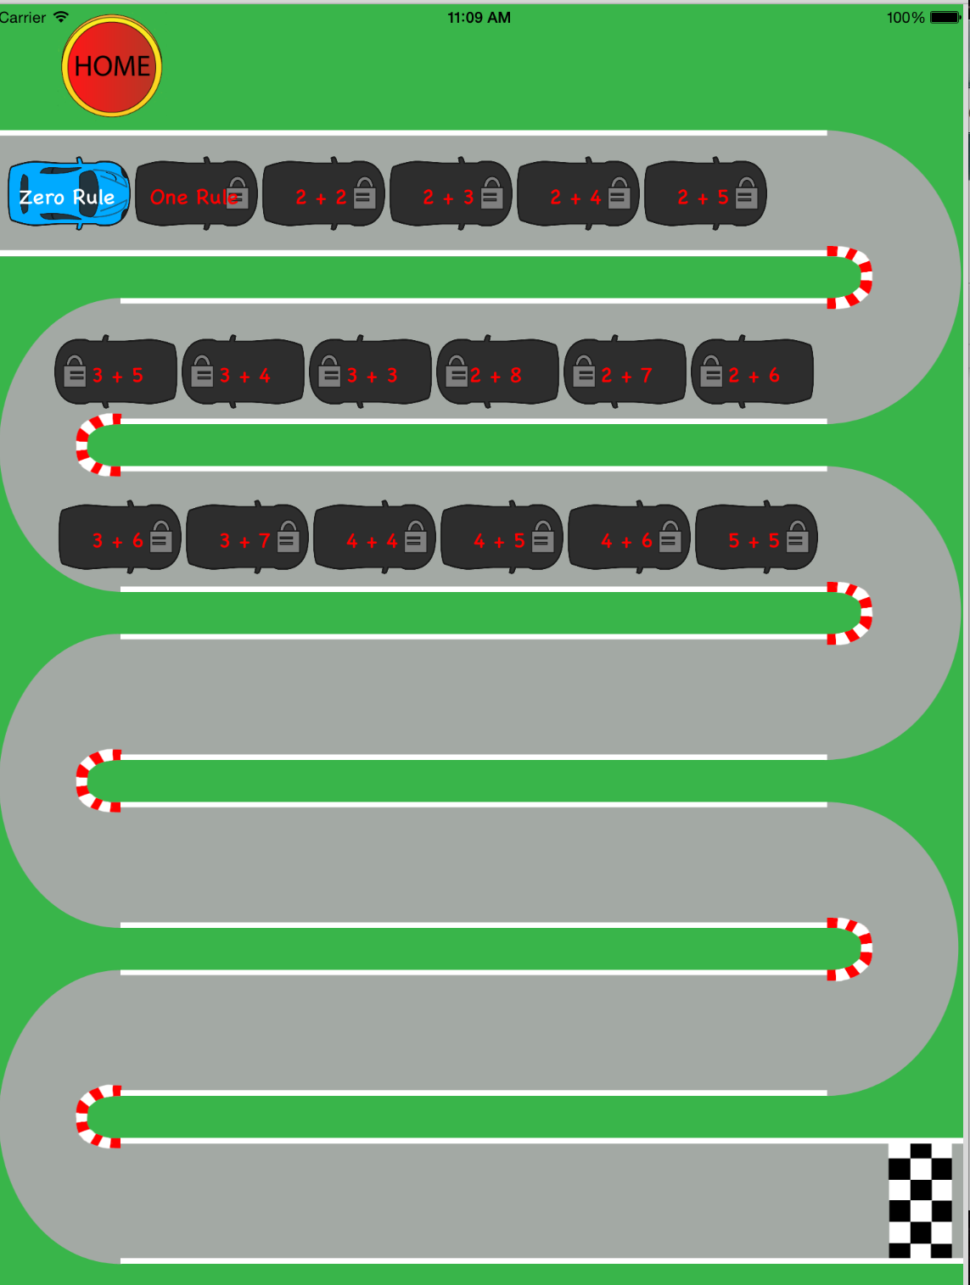

*Figure 9*

## **3.3 Selecting a type**

After the student has selected an available level it will take them to the level select screen where they will have the option to run through practice questions or take the test for that selection. (See figure 10 below).



*Figure 10*

### **3.3.1 Level type: Practice**

The student has the ability go through several practice problems within the practice level. Each submission for each problem will display a correct or incorrect box next to the questions. In the practice section there is no time restraint so the student can practice and exit the section at will.

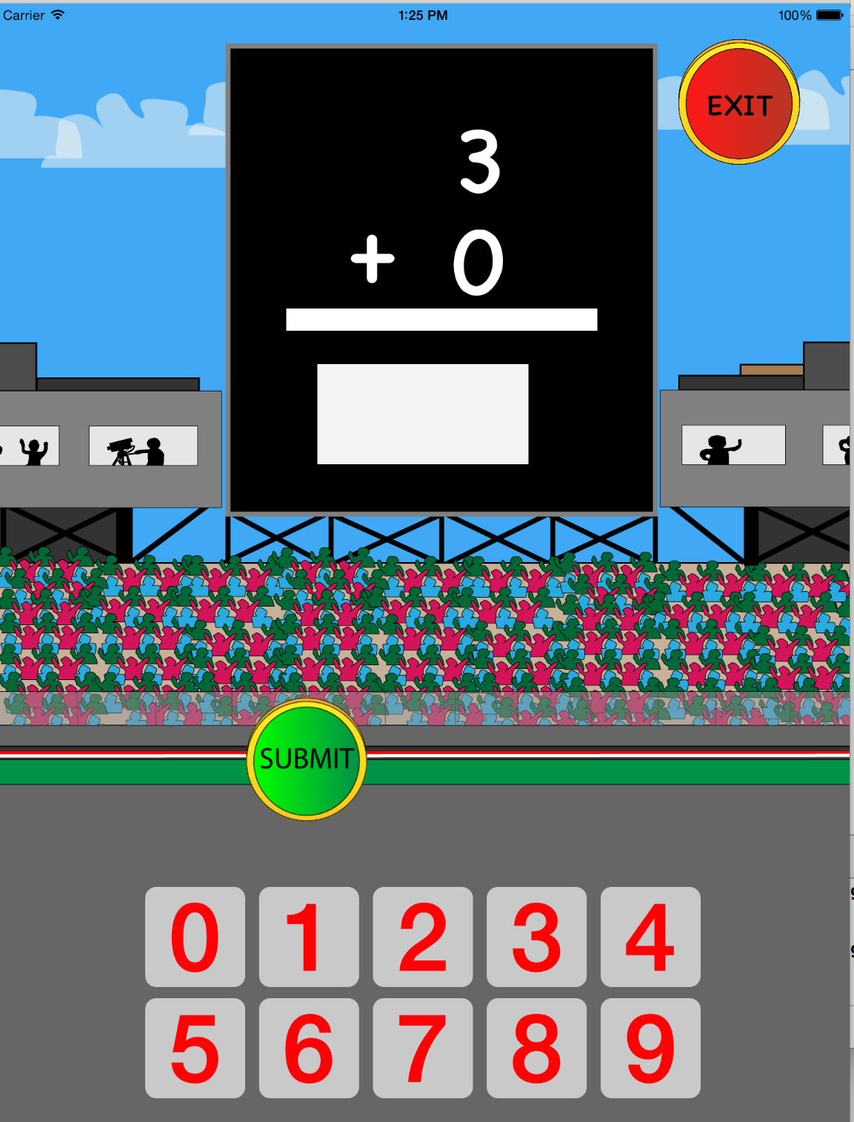

*Figure 11*

### **3.3.2 Level type: Test**

In the test view section, the students will be timed when they are answering the problems. The amount of time the student is allotted will be dictated by the teacher using the web portal. The questions in this section are questions similar to ones they have seen in the practice section. Upon completion of the test section there will be a results page displayed at the end. Any incorrect responses will be displayed on this screen along with the question and correct answer next to it. If a student cannot complete a test with 100% accuracy then the student will not be able to advance to the next section. They will the option to go to the map to select another available level or they can choose to retake the test.

## **3.4 Going through the questions**

When a student is going through either the practice levels or test levels they will encounter questions on their screen. A randomly selected question from the level that the teacher has created or questions from the default level will appear on their screen. The student will then answer the question by dragging and dropping a tile from the screen into an input box. When the tile enters the input box a green border will surround the tile indicating that it is ok to lift their finger off the screen and the input box will receive the tile as an answer (see figure 12 below). The student has the option of taking the tile out or adding in an additional tile if they choose to do so. They can repeat this step as many times as they want to, but in order to view the next question they will have to tap on the “Submit” button located underneath the input box. In the practice view when the “Submit” button is tapped a green or red box will appear indicating a correct or incorrect answer has been submitted. From the test view there will be no box indicating the accuracy of their submission and will only know the answers at the end of their test with the results display. (See figure 13)

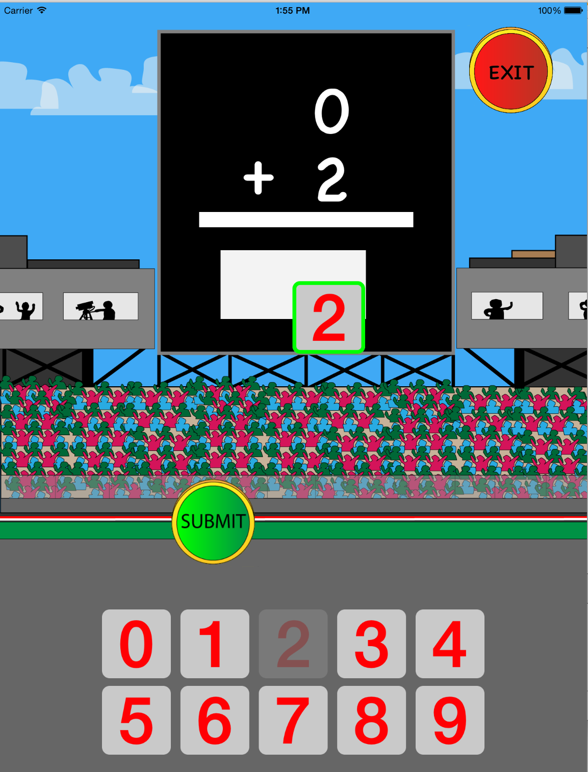

*Figure 12*

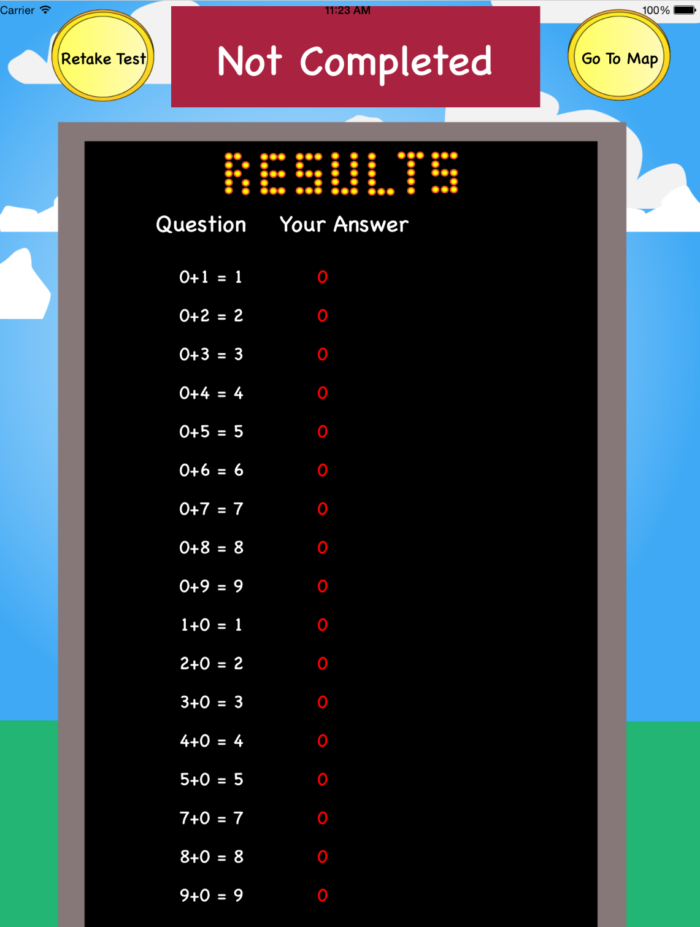

*Figure 13*

## **3.5 Submission overview**

At the end of the test portion the student will be available to view a results page that will display any incorrect submissions. On the left hand side the page will display the question and the correct answer in white and to the right of that the answer that the student submitted will be displayed in red (see figure 13 above).